Calibration of Monochromator Using Mercury-vapour Lamp

William Kemp & James Park

**Abstract:**

The monochromator is an important tool to collect photons of specific wavelengths from an incident beam.. It selects a specific wavelength by rotating a knob on the monochromator. However, we do not know what knob value corresponds to what wavelength that it selects. We used a mercury lamp (whose nominal wavelengths are known) to determine the relationship between the knob and the wavelength. Using linear regression, our result was

$λ=\left(1002.3±75.7\right)X_{inches} - 62.2 nm$, where $λ$ is wavelength in nm, $X_{inches}$ is the knob value in inches. However, there’s some error associated with our model, which we believe is due to a damaged component in the monochromator.

During our investigation of a HeNe laser, we needed to collect HeNe atomic spectral line data. The monochromator was vital to measure the intensities of atomic spectral lines at various wavelengths. We selected a wavelength by rotating a knob (measured in inches with error of an ±0.0001 inches) but didn’t know the value of the wavelength being selected. We knew that knob value was linearly proportional to the wavelength and needed to develop a relationship between the knob value and the wavelength that the monochromator selects.

We used a mercury lamp (composed of Mercury and Argon) because the nominal wavelengths for Mercury and Argon are known. The lamp emission was directed into the input slit of the monochromator while the output slit was attached by the photomultiplier tube (PMT). The PMT was connected to oscilloscope, so we could identify the atomic spectral lines (regions of high intensity) as we rotated the knob. Once emission line knob values were determined, we removed the PMT, and rotated the knob until we noticed green light. The wavelength of green light corresponds to range of 520 nm to 560 nm and only one wavelength of mercury lamp can correspond to that green light.

Since we know the knob value corresponding to the green light of mercury lamp and the fact that there’s a linear relationship between the knob and the wavelength, we can match the collected knob values and the nominal wavelength of the mercury lamp. Using the linear regression, our predicted model is

$λ=\left(1002.3±75.7\right)X_{inches}-62.2nm$. We ignored the uncertainty of the knob measurement in the linear regression because the uncertainty is insignificant compared to that of the fit.

The uncertainty of the output wavelength was $δλ=75.7X_{inches}$ and our knob measurement varied from 0.44 to 0.83 inches, so the uncertainty of wavelength ranges from 33.3 nm to 62.8 nm.  This uncertainty was significant when compared to the difference in some Neon atomic spectral lines and made precise matching of transition level to spectral line difficult. An observation made from the linear regression was that there were two points which didn’t match a linear fit, indicating that perhaps the linear stage used to adjust the monochromator was damaged in some way.  While using the linear stage, we noticed it was bent, causing it to stick in some places, and perhaps indicating that the translation of the stage was not always linear to knob rotation.

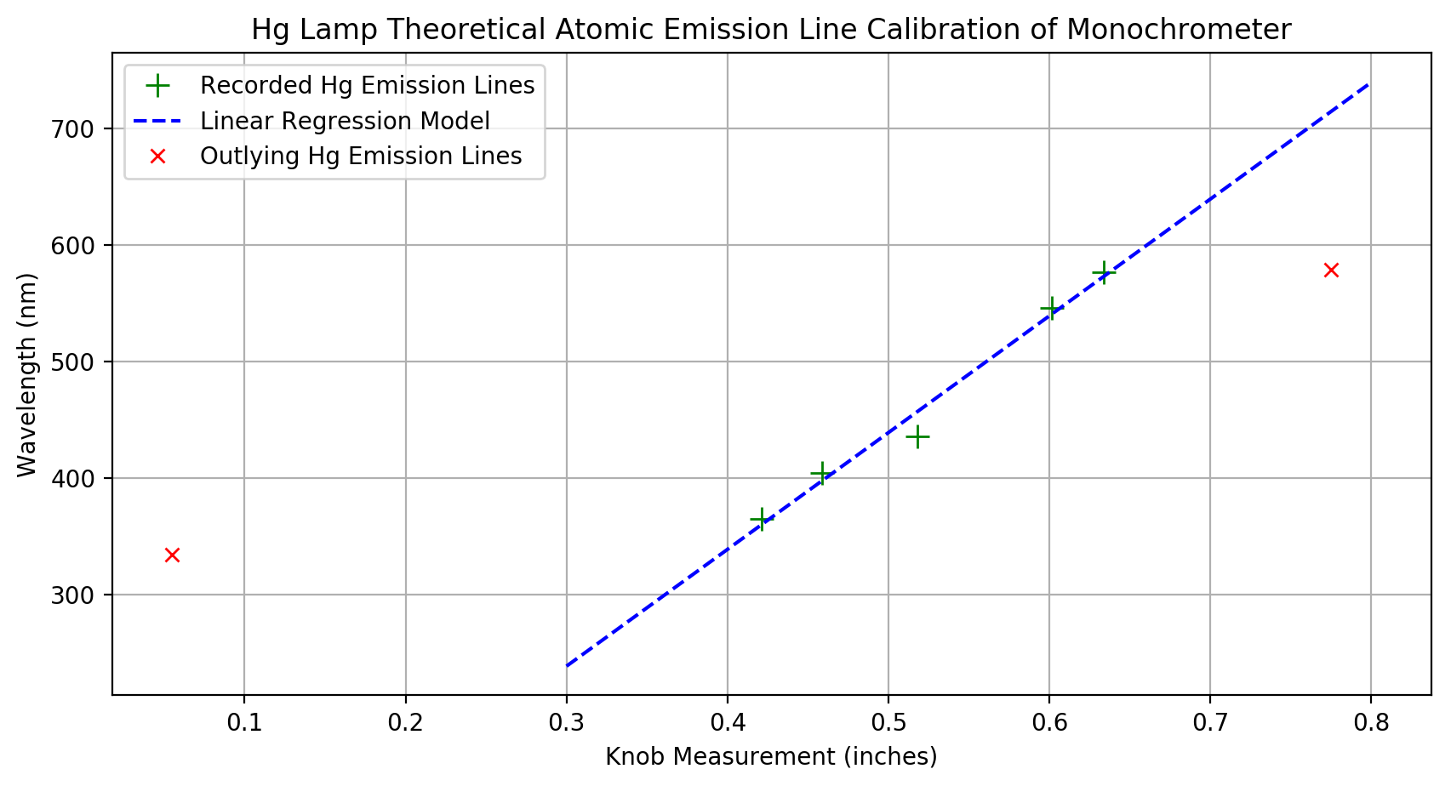

Figure 1: Plot containing the series of emission lines detected from the monochromator at various linear stage settings (in inches). The vertical axis demonstrates the theoretical wavelengths of emission lines in the Hg lamp, while the horizontal axis represents the reading from the linear stage. A relationship between the theoretical emission lines, and the linear stage position at each of these emission lines is composed in the form of a linear fit (blue dotted line). Two outlying Hg emission lines (in red) were ignored since they didn't correspond to a linear relationship. Reasoning behind ignoring the two outliers is due to the fact that the monochromator’s linear stage appeared damaged, and so didn't necessarily translate properly at the extremes of its range.